Tom P. 9-5

How to Assignment: How to open Pivot Stick figure Animator

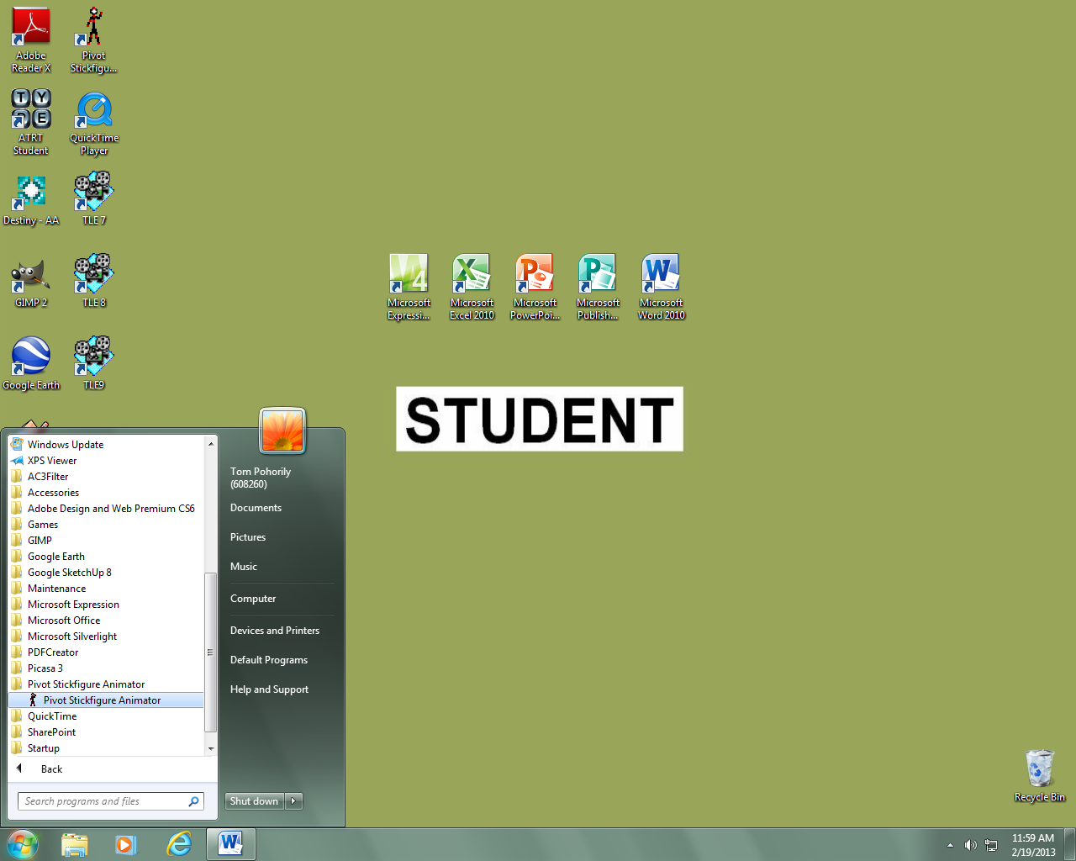

**Step 1**

**Step 3**

**Step 4**

**Step 2**

Go to the start menu, click on all programs which will open a list of all your programs, click on the Pivot Stick figure Animator file then click on the Pivot Stick figure Animator program.

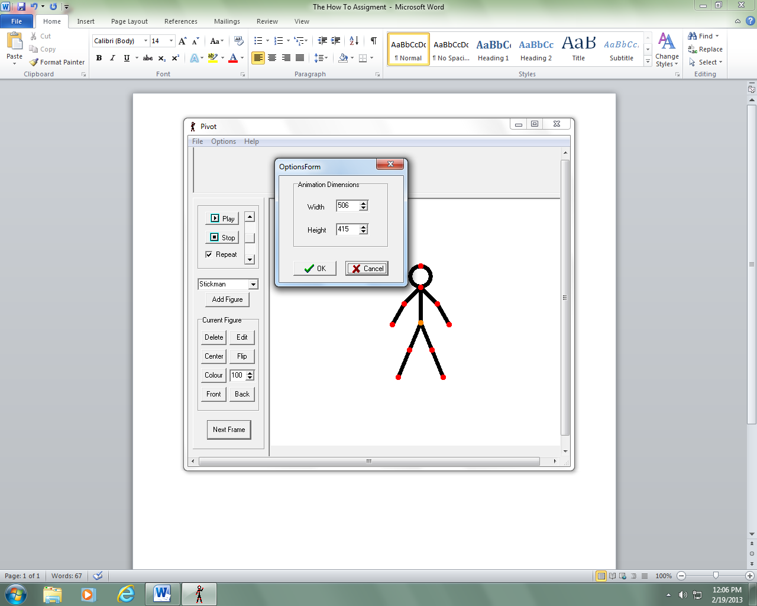

**Step 1**

**Step 2**

**Step 3**

Go to file located at the top left hand corner and click on create figure type. By doing this, It will open up a window showing options allowing you to edit the figure type(s). Click on file and click add to animation to add it to the animation.

Click on options and a window will pop up showing you what you want your animation dimensions to be. Set your dimensions and click ok.

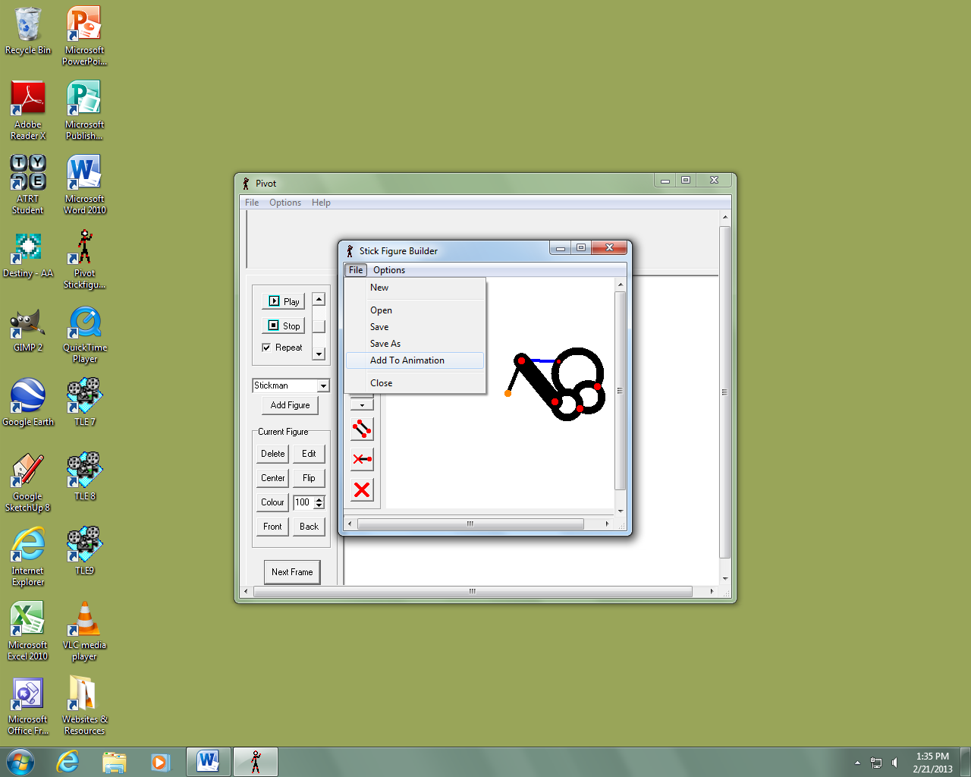

**Step 3**

**Step 4**

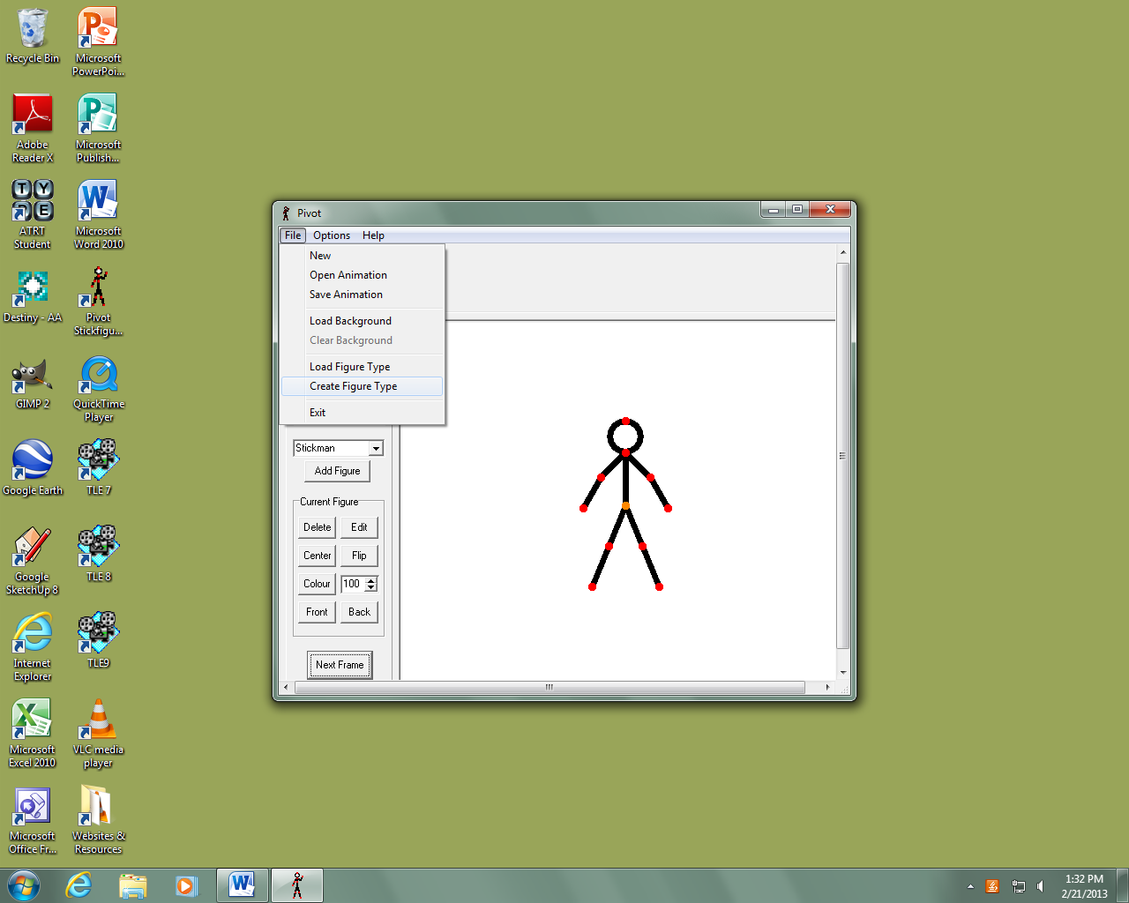

**Step 1**

**Step 2**

**Step 5**